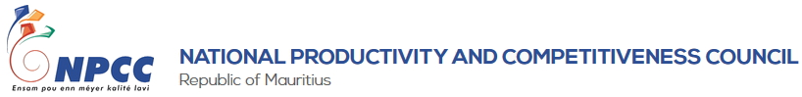
PRESS RELEASE
Best national projects awarded during NLE Convention
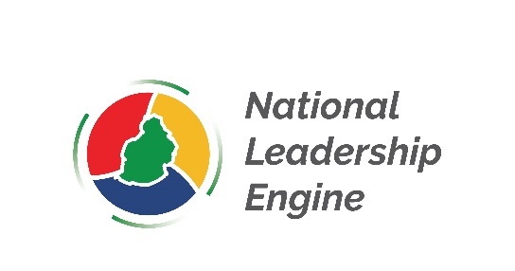

Ebène, 26 February 2022: The third edition of the National Leadership Engine (NLE) project culminated today with a National Convention during which the grand winner and the two runner ups projects were announced.

The event which was held online was attended by more than 300 participants as well as former participants and other youths who are now part of the NLE Action Drivers (NLEAD) network.

The winners are as follows:
Grand Winner: Team Algo Plastic (Montagne Blanche Youth Centre)
Second Winner: Team Smart Hands (NPCC, Ebène)
Third Winner: Team Pa Zet Narien (Mahebourg Youth Centre)

NLE 2021 was organised by the NPCC in collaboration with the Ministry of Youth Empowerment, Sports and Recreation. The project aims at creating a pipeline of leaders to achieve higher productivity and better living for the nation.

The first phase, launched in April 2021, consisted of the training of co-trainers whereby more than 100 participants were trained to become co-trainers. During the second phase, more than 350 youth enrolled for the training which was delivered online for the following regions namely, Bambous, Barkly, Floréal, Montagne Blanche, Mahebourg, Pamplemousses, Port Louis, Rivière du Rempart, Souillac and Ebène.

Youth aged 16 and above were empowered with personal and social competences which they had to demonstrate by conceptualising and implementing community-based projects in their locality. The training for youth was completed in September 2021, followed by regional assessments of projects and a national assessment that were held in October 2022. A total of 52 community based projects were presented in NLE 2021. The projects focused a range of issues pertaining to the environment, animal rights, mental health amongst others.

The Executive Director of the NPCC, Mr. Ashit Gungah, stressed on the importance of values which are critical to tackle the numerous challenges that our country is facing. He urged young people to take advantage of latest technologies, particularly social media, to interact, learn and share with their peers both in Mauritius and abroad.

“Today, we have to look at the world from different perspectives and come up with solutions to improve the lives of people. It is sad that our youth have become victims of drugs, prostitution and crime. Along with this, we also have a mentality of individualism that has developed. We have to be conscious that we live in a society and we have to work together for a better quality of life. It is important that youth, who are adults of tomorrow, realise that they have a critical role to play in bringing a positive transformation in the society,” Mr. Gungah pointed out.

The Minister of Industrial Development, SMEs and Cooperatives, Honorable Soomilduth Bholah, in his speech, motivated the youth to take a strong interest in entrepreneurship. “Aspiring young entrepreneurs can explore new areas including renewable energy, aquaponics and artificial intelligence. We need innovative young people to create a new generation of entrepreneurs,” he pointed out.

The Minister of Youth Empowerment, Sports and Recreation, Honorable Stephane Toussaint urged youth to take an active role in developing solutions to tackle climate change. He explained that our youth are being continuously empowered to participate and give a helping hand in projects that aim at enhancing people's lives.

It is worth noting that ten freshly registered associations comprising former participants of the NLE project signed an agreement with the NPCC recently, paving the way towards a solid formal cooperation under which the NPCC will offer them support in terms of management and project implementation.

The regional lead associations have already started developing and implementing community based projects. The NPCC has offered each association a grant of Rs 15,000 that will help them fund their initiatives. The NPCC is also planning specific training in areas which will help them further develop the required leadership skills.

About the NLE project
The NLE project aims to develop leadership capabilities among youth. Leadership is a stepping stone for youth to participate in building effective, accountable, and inclusive communities in Mauritius. The NLE is an initiative of the NPCC in collaboration with the Ministry of Youth Empowerment, Sports and Recreation with the objective of developing a leadership pipeline to achieve higher productivity and a better living for the nation.
-End of press release-
Note to Editors
The NPCC was set up in 2000 after the enactment of the National Productivity and Competitiveness Council Act No. 9 in 1999 with the objective to stimulate and generate productivity and quality consciousness and drive the productivity and quality movement in all sectors of the economy. The NPCC operates five distinctive units namely Capacity Development, Corporate Services and Operations; Business Development and Consultancy; Innovation, Advocacy and Entrepreneurship; Research, Advisory and Knowledge Management and Productivity and Competitiveness Learning Centre.

For more information, please contact:
Debesh Beedasy
Communications, Public Relations and Marketing Specialist
National Productivity and Competitiveness Council (NPCC)
3rd Floor, The Catalyst
Silicon Avenue, Cybercity
Ebène 72201, Mauritius
Tel: (230) 467 7700/ (230) 5 729 7700
Fax: (230) 467 3838
Email: npccmauritius@intnet.mu
www.npccmauritius.org

