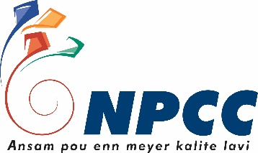
National Productivity and Competitiveness Council

ENTERPRSE COMMITMENT FORM

Course on
‘Occupational Health and Safety’

Company Name:
Contact Person:
Address:
Telephone:
Fax:
Company Email:

I, ……………………………………….., on behalf of …………………………………….. commits that representative of the company will attend the training. I also give my assent to the NPCC to use my case study for knowledge dissemination and marketing purposes.

The company also commits to attend the Training of Enterprises both face to face and online and to complete the Occupational Health and Safety by the 11th of November 2020.

Please send completed form to knowledgecentre@npccmauritius.com
For more information please contact Shalini Mathaven/ Shalini Panchoo on 467 7700.

Note: By providing the above data you consent to your data being collected and processed as part of the requirements of the training at the National Productivity and Competitiveness council (NPCC). Your data will be stored and you might be contacted concerning other NPCC events and/or activities. Should you wish to withdraw your consent at any time or if you require more information, please contact the NPCC at npccmauritius@intnet.mu or on 467 7700.

