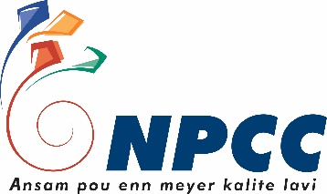
National Productivity and Competitiveness Council

REGISTRATION FORM

Course on
‘Business Continuity and Resiliency Planning’

Company Name:
Contact Person:
Address:
Telephone:
Fax:
Company Email:

Participants’ Name | Official Designation | Email

Note: By providing the above data you consent to your data being collected and processed as part of the requirements of the training at the National Productivity and Competitiveness council (NPCC). Your data will be stored and you might be contacted concerning other NPCC events and/or activities. Should you wish to withdraw your consent at any time or if you require more information, please contact the NPCC at npccmauritius@intnet.mu or on 467 7700.

