THE SECRETS TO INNOVATION (PART 1)
Undoubtedly the capability to innovate and to bring innovation successfully to the market is a crucial determinant of competitiveness today. While small and medium enterprises (SMEs) continue to be the backbone of the Mauritian economy contributing to nearly half of total employment and about 35% of Gross Value Added (GVA), technological innovations, unpredictable, rapidly customers’ requirements and the recent economic and financial crisis are putting SMEs under pressure to innovate and re-adjust their business strategies and planning.

History offers numerous examples of companies that failed to adapt to changes. Perhaps one of the most notable examples of such a failure is Kodak. From being among the leading brands in photography, the company filed for bankruptcy protection in 2012, exited legacy businesses and sold off its patents before re-emerging as a sharply smaller company in 2013. Once one of the most powerful companies in the world, today the company has a market capitalization of less than $1 billion (Harvard Business Review, July 2016).

So, as entrepreneurs how do you avoid the same fate as Kodak? How to innovate? Where to start? Who should innovate? These are some of the most pressing questions which we usually ask ourselves.
The Concept of Innovation (Source: Developing-Country Capabilities and the Unrealized Promise of Technological Catch-Up, World Bank Group, 2017)

Innovation means different things to different people. The Schumpeterian view of innovation is one of the more useful ways to understand the concept. Innovation can be defined as the ability to use knowledge to develop and apply new ideas that result in changes in the production and organizational structure of the firm. Schumpeter (1934) defined several of these applications that qualify as innovation:
- Introduction of a new product or modifications to an existing product
- A new process or technology in an industry
- The discovery of a new market
- Development of new sources of supply of inputs and raw materials
- Changes in industrial organization

Innovation is, therefore, broader than invention. It includes commercial applications of new technology, new material, or new methods and processes. It primarily involves the process of adoption of existing technologies, the process of copying or imitating attributes from other products, or the adoption of new managerial and organizational practices or business models from other companies.

Innovation also includes the invention of new technologies and disruptive business models. Although important, these are a small part of the innovation process, especially in those countries farther away from the technological frontier. The popular view of innovation that understands innovation primarily as invention, patenting, or the generation of disruptive technologies misses the larger part of the innovation process—the more incremental implementation of ideas and knowledge to improve the firm.
An implication of this broader view of innovation is the fact that firms accumulate knowledge to apply these new ideas in different ways. These include not only research and development activities but also other knowledge accumulation activities, often informal or through collaboration with other firms, through learning from clients, or by participating in global value chains or international markets.

Secret 1: Challenging Assumptions
"If you always do what you've always done, you'll always get what you've always got." Henry Ford (1863-1947), American founder of the Ford Motor Company.
There are many ways we get stuck into patterns of thinking and doing, making innovation difﬁcult. Some of the most established characteristics of products, services, business models, environments and just about any other designable thing are subject to change at any given time. Challenging your assumptions about the product or service you are offering is the starting point for innovation. If you don’t spend time upfront understanding your customer and their needs then you’re likely to offer the wrong thing.
If they can, why not you?

The Chinese Dosawala
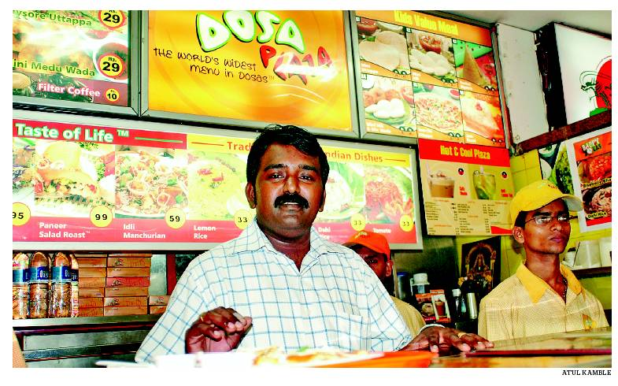
My name is Prem and I dreamt to become a big businessman someday. I started cleaning utensils in a restaurant and wanted to become waiter because I was class 10 pass. After a number of challenges, I began to muster courage and determination to work for myself. I took a loan from my uncle and brother and build by Indian stall. I did not know a thing about Dosas and Idli but learnt by observation, trial and error. The dosa stall was a huge success and flourished during the 5 years from 1992-1997. I was successful and could beat competition because of my hygiene, grooming of waiters and fresh ingredients used in dosas.

I put some money aside and instead of saving it, I took the biggest risk of my life and opened a new shop which I named the Dosa Plaza. The Chinese plaza next to the Dosa Plaza flopped miserably and was closed in 3 months. Undaunted and innovative, through trials and errors, I created a Chinese dosa by inculcating the Chinese cuisine while making the dosas. I was passionate and invented a variety of dosas with Chinese style like American Chopsuey, Schezwan Dosa, Paneer chilly, Spring roll dosa and so on. In total, I made 108 types of Dosas in my menu. Dosa Plaza currently has 26 outlets and 5 of them are company owned.
https://edcdduc.wordpress.com/2015/09/29/prem-ganapathy-the-dosawala-a-story-of-pure-perseverance-and-doing-what-you-love/

From Pig supplier to gas supplier
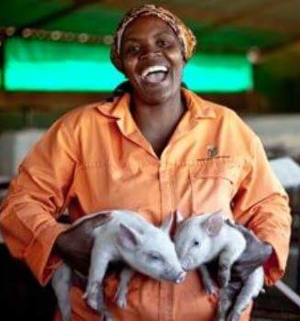
My name is Anna Phosa and I have a small business of rearing pigs. The journey I undertook was not rosy. I struggled a lot to ra ise capital to start and grow the business. In 2004, I started my first pig farm in Soweto, South Africa with $100 from my personal savings. I started with only 4 small pigs. After four years, in 2008, I was contacted by Pick’n Pay, the South African supermarket chain, to supply its stores with 10 pigs per week. This was a first breakthrough and the request grew quickly to 20 pigs per week. By 2010, I had signed a major contract with Pick’n Pay to supply 100 pigs (per week) over the next five years under a R 25 million deal, that was nearly $1.9 million.

With a contract in hand, I was then able to raise capital from ABSA Bank and USAID to buy a 350-hectare farm property. Today, my farm houses 4,000 pigs at a time and employs about 20 staff. I knew that to stay in the market and to meet the demands I needed additional revenues and it was important for me to be innovative. I then researched and installed pipes in my farm houses to generate kitchen gas from pigs’ waste. This enlarged my port folio of activities and enabled me to be profitable by selling gas to the neighbourhood.
http://www.theamazingvillage.com/anna-phosa-one-of-south-africas-biggest-pork-supplier/

Challenge your assumptions
- What new food products could we bring to the market using our existing expertise? Can we for instance think about a new type of “dholl purri” which Mauritians and foreigners can relish?
(Write to us on our blog)

